Removing MipMaps

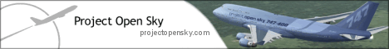

This tutorial will show you basically how you can remove mipmaps from a texture. I hope you can learn something with this tutorial.

We will need a program called Imagetool. Get the latest version here (in paint-resources section):

www.projectopensky.com/files

Download, and install the little program. When you are done, open it.

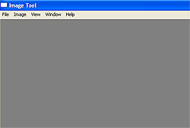
Opening screen Imagetool.

Now the real work!
- Go to file → Open
- Open the texture you want, you can find those in the “texture” folder of your aircraft (main FS folder / Aircrafts / your_plane / texture)
- Go to Image and click “extract mipmaps” (see image under).
- You will see lots of images, select the one with number 0 (xxx_t_0.bmp)
- Save this one as the original texture (see second image under). Don’t forget to make sure you save it as .bmp file. Overwrite the old one. That’s all!

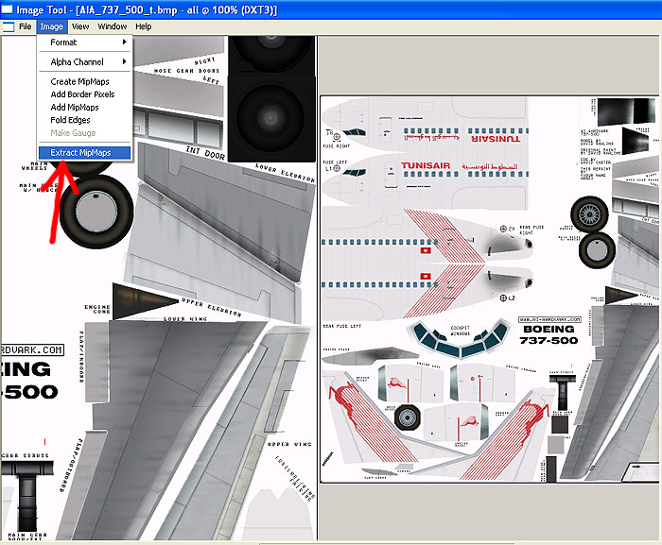
You see lots of images. Click “extract MipMaps”, after that select the xxx_t_0.bmp one!

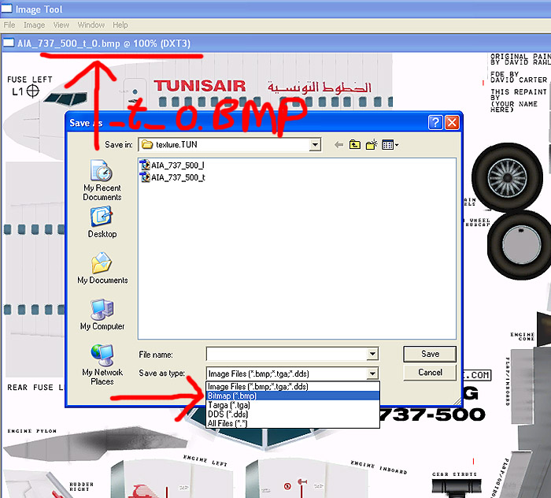

********** COPYRIGHT AND DISTRIBUTION **********

This tutorial is released as FREEWARE.

Copyright (C) Project OpenSky . All rights reserved.

**This file may NOT be modified and distributed without permission from the author **

© Albert Bouwman

